Questions:
- What is relationship between Person and Student : has (composition) or is-a (inheritance)

- How about Customer and Account?

- Draw a inheritance hierarchy for the following classes:
Circle, Triangle, Square, Cube, Sphere, Ellipse, Quadrilateral, Shape, Two-D-Shape, Three-D-Shape, Parallelogram

- Quadrilateral is a ______________________ of Triangle.

- Two-D-Shape is a _____________________ of Triangle.

- Every class extends _____________ class.

True or False Questions:
- superclass protect method are inherited by all subclasses of that superclass. (True or False)
- Constructor of superclass can be inherited to subclass.(True or False)
- We can explicitly call superclass constructor using super() (True or False)
- Constructor can be used to initial the values of instance variables of an object (True or False)
- getXXX() method can be used to get private instance variables.(True or False)
- One of the drawbacks of using protected is that subclass can change superclass variables directly (True or False)
- Another drawback is that if superclass variable names change, subclass variables also need to be changed everywhere(True or False)

For this example, we will design three classes:
  - Student
  - UndergraduateStudent
  - GraduateStudent

The Student class will incorporate behavior and data common to both UndergraduateStudent and GraduateStudent objects.The UndergraduateStudent class and the GraduateStudent class will each contain behaviors and data specific to their respective objects.

/*
File: Student.java
*/
class Student {

protected final static int NUM_OF_TESTS = 3;
protected String name;
protected int[] test;
protected String courseGrade;

public Student( ) {
this("No Name");
}

public Student(String studentName) {
name = studentName;
test = new int[NUM_OF_TESTS];
courseGrade = "****";
}
public String getCourseGrade( ) {
return courseGrade;
}
public String getName( ) {
return name;
}

public int getTestScore(int testNumber) {
return test[testNumber-1];
}

public void setName(String newName) {
name = newName;
}

public void setTestScore(int testNumber, int testScore) {
test[testNumber-1] = testScore;
}
}

/*
File: UndergraduateStudent.java
*/

class UndergraduateStudent extends Student {

public void computeCourseGrade() {
int total = 0;

for (int i = 0; i < NUM_OF_TESTS; i++) {
total += test[i];
}

if (total / NUM_OF_TESTS >= 70) {
courseGrade = "Pass";
} else {
courseGrade = "No Pass";
}
}

/*
File: GraduateStudent.java
*/

class GraduateStudent extends Student {

public void computeCourseGrade() {
int total = 0;

for (int i = 0; i < NUM_OF_TESTS; i++) {
total += test[i];
}

if (total / NUM_OF_TESTS >= 80) {
courseGrade = "Pass";
} else {
courseGrade = "No Pass";
}
}
}

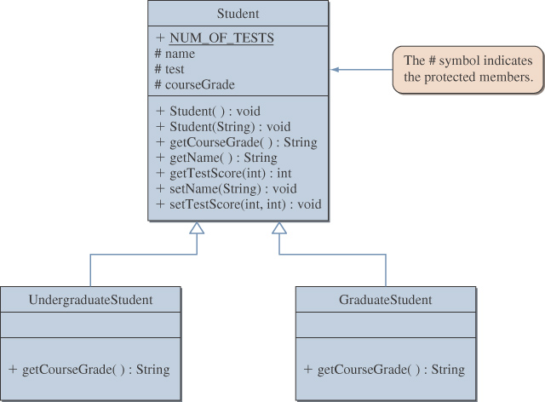

Polymorphism allows a single variable to refer to objects from different classes.

For example, if we declare
Student student;
We can say
student = new Student();
student = new GraduateStudent();
and
student = new UndergraduateStudent();

We can maintain our class roster using an array, combining objects from the Student, UndergraduateStudent, and GraduateStudent classes.
Student roster [40];
roster[0] = new GraduateStudent();
roster[1] = new UndergraduateStudent();
roster[2] = new UndergraduateStudent();

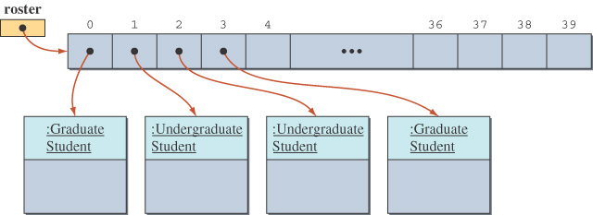
The computeCourseGrade method is called polymorphic because the message refers to methods from different classes depending on the object referenced by roster[i].

Polymorphism, as you can see, permits the smooth and easy extension and modification of a program.

Student x = new UndergraduateStudent();
if(x instanceof UndergraduateStudent ){
System.out.println(“Mr. X is an undergraduate student”);
}else{
System.out.println(“Mr. X is a graduate student”);
}

abstract class Student {
protected final static int NUM_OF_TESTS = 3;
protected String name;
protected int[] test;
protected String courseGrade;

public Student() {
this(“No name”);
}

public Student(String studentName){
name = studentName;
test = new int[NUM_OF_TESTS];
courseGrade = “******”;
}

abstract public void computeCourseGrade();

public String getCourseGrade(){
return courseGrade;
}
public String getName(){
return name;
}
public int getTestScore(int testNumber) {
return test[testNumber-1];
}
public void setName(String newName){
name = newName;
}
public void setTestScore(int testNumber, int testScore){
test[testNumber-1] = testScore;
}
}

